MVWF_PERMIT front end screen shots
Parameter form
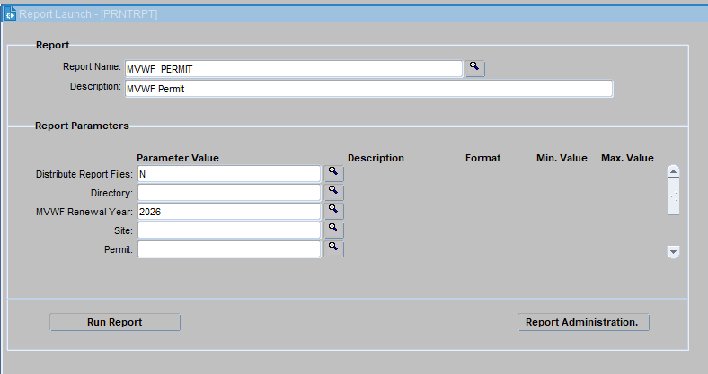
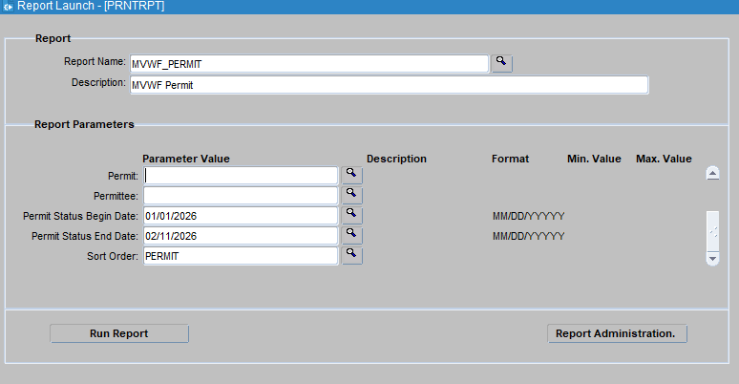

Ran report in production using renewal year, permit status begin date and permit status end date
http://cedars.deq.mt.gov/reports/rwservlet?DEQ&destype=cache&desformat=PDF&report=MVWF_PERMIT.rep&P_DISTRIBUTE=N&P_RENEWAL_YEAR=2026&P_STATUS_DT_BEGIN=01/01/2026&P_STATUS_DT_END=02/11/2026&P_SORT=PERMIT
